**Final Project**

**Executive Summary**

Idaho is currently a two congressional district state. Redistricting the state requires careful attention to detail in order to abide by all federal and state laws. In order to abide by these laws we created a program that allows us to redistrict the counties evenly by population. Even population districting allows for equal votes and by doing so we create a better way to vote for all of the people in idaho. By avoiding gerrymandering and using our program we have redistricted in a way which keeps all current counties intact to avoid confusion and allow for simplicity. The main changes are counties in the central part of the state have been redistributed in order for the population of both districts to be evened out.

**Introduction**

Redistricting is required as the population in Idaho has grown in specific counties so voting can be equal and fair. Due to state and federal laws it is required that we make sure the final redistricting plan is within those boundaries.

**Criteria**

In terms of criteria for redistricting for the state of Idaho, there are four major requirements: the districts need to be “compact, contiguous, preserve political subdivisions, and preserve communities of interest”, and when redistricting, “protecting a party or the incumbent” is prohibited. These rules are important because dividing up the districts requires precision, and these criteria that are in place as stated in the Idaho Constitution and the Idaho Code allow for this. This also avoids political biases and gerrymandering as the requirement of preserving the subdivisions and communities of interest and the prohibiting of the protection of a party or the incumbent.

**Problem Statement**

The problem with the current Idaho distribution map is the fact that there is a denser population in certain counties of the state. This includes a more recent surge in population in Boise, the capital, and the sheer amount of people in Ada county being more than twice the amount of people in the next biggest county of Canyon. Therefore, an update to the redistricting map is needed in order to make the voting and the districting as a whole more fair and even across the board.

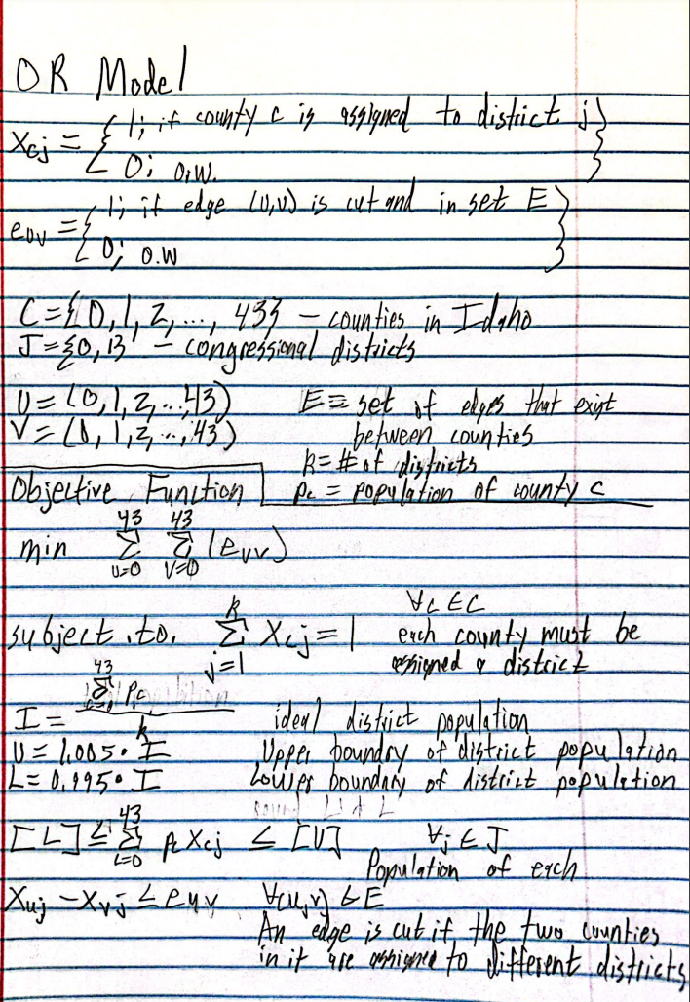

**OR Model**

Our model seeks to minimize the amount of cut edges in the map. We define cut edges by a border between a county that is split between districts. The constraints used by our model are that each county must be assigned to a single district. Also, each district's population must be within a 1% range of half of the total population. The code built was based off of these base restrictions.

**Experiments**

The experiments were performed on a laptop with an AMD Ryzen 9 6900HS CPU and 16 GB of RAM. The CPU contained 8 physical cores and 16 threads. The Gurobi version used was 11.0.0 build v11.0.0rc2 with an academic license. The objective value found was 11 cut county edges. To reach this conclusion, Gurobi required 0.16 seconds and this solution was found to be optimal.

**Plans**

Our plan would place whole counties into two separate districts. The first district (or district 0 in the code) would consist of Boundary, Bonner, Kootenai, Benewah, Latah, Shoshone, Clearwater, Nez Perce, Lewis, Idaho, Adams, Washington, Payette, Gem, and Ada County. These counties represent the northern section of Idaho and the color blue on the map. District 2 consists of the rest of the counties in Idaho and represent many more by number. This district is represented by yellow on the map. The population of district 1 is 917,997 while district 2’s population is at 921,109. Each of these populations are well within the Upper and Lower bounds set by having a tolerance of 1%.

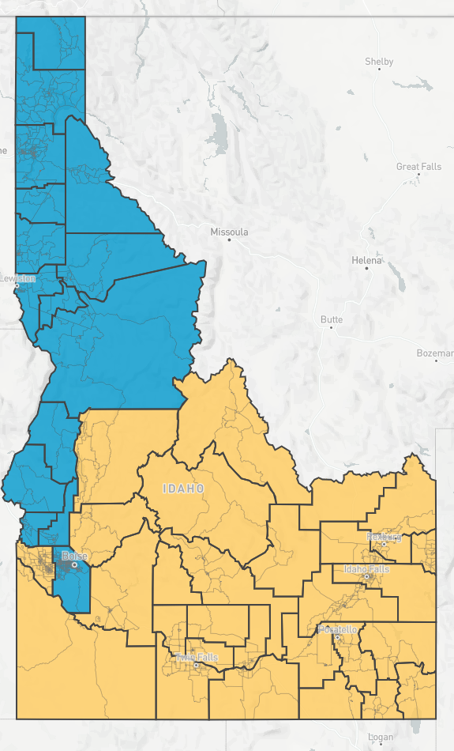

**Evaluation of Plans**

Redistricting in this way changes the two districts slightly. As the counties are remaining whole in the map, a few counties switch districts from one to the other, evening out the population discrepancy better than the previous map. These meet the criteria as keeping the counties whole ensure that the map districts are still contiguous while preserving the political subdivisions and the communities of interest. Another reason for the counties remaining whole aids in the prohibition of protecting a party or incumbent as there are no true biases within a full county. The limitations with this plan however is that while the counties remaining whole means that the districts are a little less compact as the population via county drastically differs between them. For example, Ada county, the highest population, has over 500,000 people, but Clark county has less than 1,000. Because of this, the districts are slightly more spaced out.

**Conclusions**

The new districting map that has been proposed is one that has been calculated by a given criteria and creates fairness when voting. As seen in the new map the problem of counties having higher population densities but not equal votes is no longer a problem. The new districting map also keeps the populations of the districts within a 1% tolerance of each other while keeping all counties whole.

**References**

“Resources.” *National Conference of State Legislatures*, www.ncsl.org/our-work. Accessed 11 Dec. 2023.

Bureau, US Census. “2020 Census.” *Census.Gov*, 29 Nov. 2022, www.census.gov/programs-surveys/decennial-census/decade/2020/2020-census-main.html.